

CitiusTech User Guide

NextGen Connect Server Monitoring Dashboards

Version 1.0



Copyright

This document is CitiusTech Internal and contains proprietary information, including trade secrets of CitiusTech. Neither the document nor any of the information contained in it may be reproduced or disclosed to any unauthorized person under any circumstances without the express written permission of CitiusTech.

Intended Audience

This document is intended for the users of CitiusTech’s NextGen (previously known as Mirth) Connect server monitoring dashboards developed for monitoring the server health of NextGen Connect servers.

Revision History

|  |  |  |  |  |  |
| --- | --- | --- | --- | --- | --- |
| Document Version # | Revision Date | Prepared By | Approved By | Approval Date | Summary of Changes |
| 1.0 | 27-07-2020 | Pravin Gadade |  | Click here to enter a date. | First Version |
| 1.1 | Click here to enter a date. |  |  | Click here to enter a date. |  |
| 1.2 | Click here to enter a date. |  |  | Click here to enter a date. |  |

How to Use this Document (Optional)

This user guide provides a suggested workflow and step-by step walkthrough of the various dashboard screens of NextGen Connect Dashboards. Use this document as a guide to log in to NextGen Connect dashboards and view various screens on dashboards.

Before you Begin

To use this guide successfully, end-users must have :

1. Valid link of Grafana based NextGen Connect server monitoring dashboards and
2. Valid login credentials for login to access the dashboards

Acronyms and Abbreviations (Optional)

This section defines the acronyms and abbreviations used in the document.

|  |  |
| --- | --- |
| Term | Definition |
| Instance | This term identifies the NextGen Connect server instance name on the dashboard |
| Channel | Channel represents the integration interface configured on each NextGen Connect server instance. There can be around 150+ interfaces configured on each of the server instance. |
| CT | CT is the short form of term ‘CitiusTech’. |

Contents

1 Step by Step User Guide 6

1.1 Logging in to NextGen Connect Server Monitoring Dashboard 6

1.2 Using Mirth Metrics Dashboard 7

1.3 Drill down Views: 9

1.3.1 Drill down from Server Monitor Section: 9

1.3.2 Drill down from Interface/Channel Monitor Section 11

# Step by Step User Guide

This section describes step by step process to access the NextGen Connect Server monitoring dashboards.

## Logging in to NextGen Connect Server Monitoring Dashboard

1. Open the Grafana based NextGen Connect dashboards by clicking on the following link. You will be navigated to ‘Welcome to Grafana’ screen. :

<http://40.114.69.75:9000/d/4mywzPZGz/mirth-metrics-dashboard?orgId=1&refresh=1m>

1. Enter valid username and password on login screen to access the Grafana dashboards.

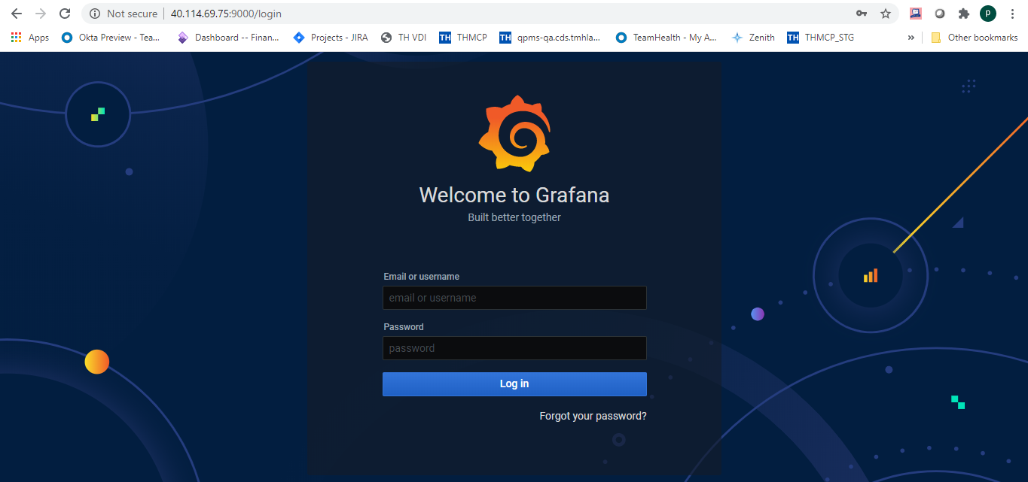

1. After logging in, click on ‘Search’ icon on the ‘Home’ screen of Grafana dashboard.

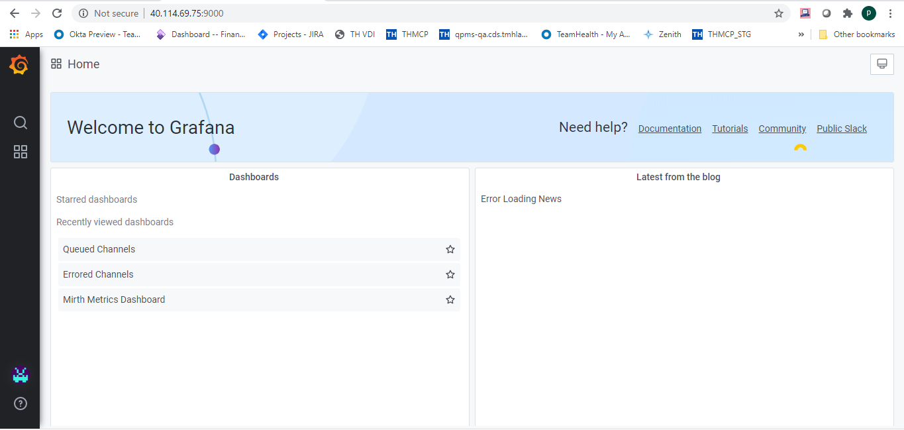

1. Select the ‘List’ icon to list the dashboards and select the ‘Mirth Metrics Dashboard’ card for logging in to ‘ Mirth Metrics Dashboard’.

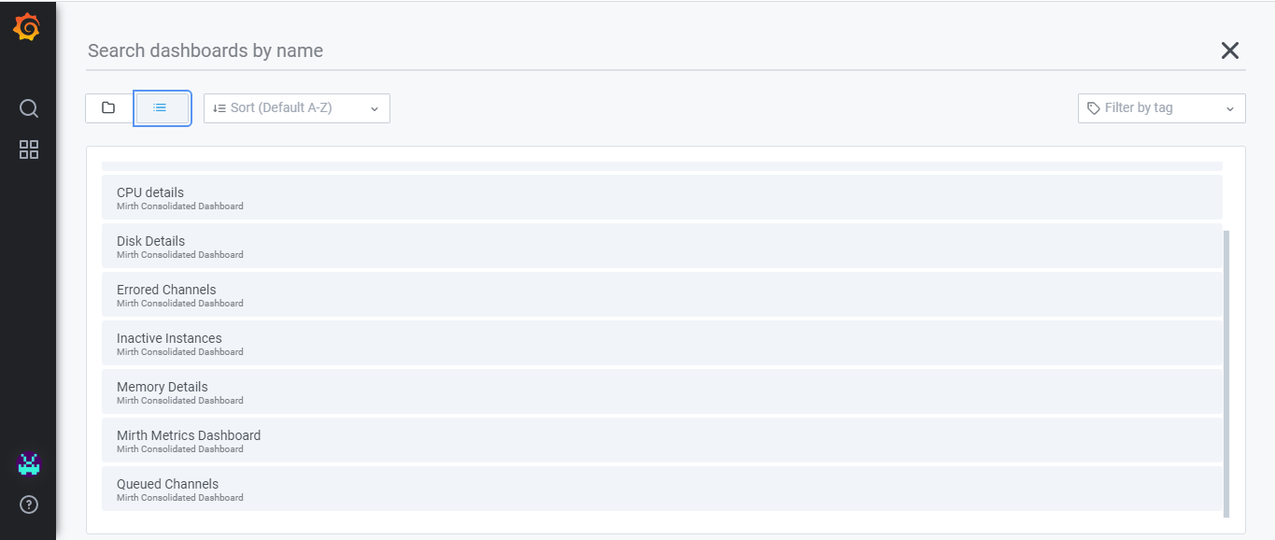

## Using Mirth Metrics Dashboard

1. Landing screen of this dashboard is Mirth Metrics Dashboard and it has four sections as follows:
   1. Header Section
   2. Server Monitor Section
   3. Channel/Interface Monitor Section and
   4. Throughput Monitor Section

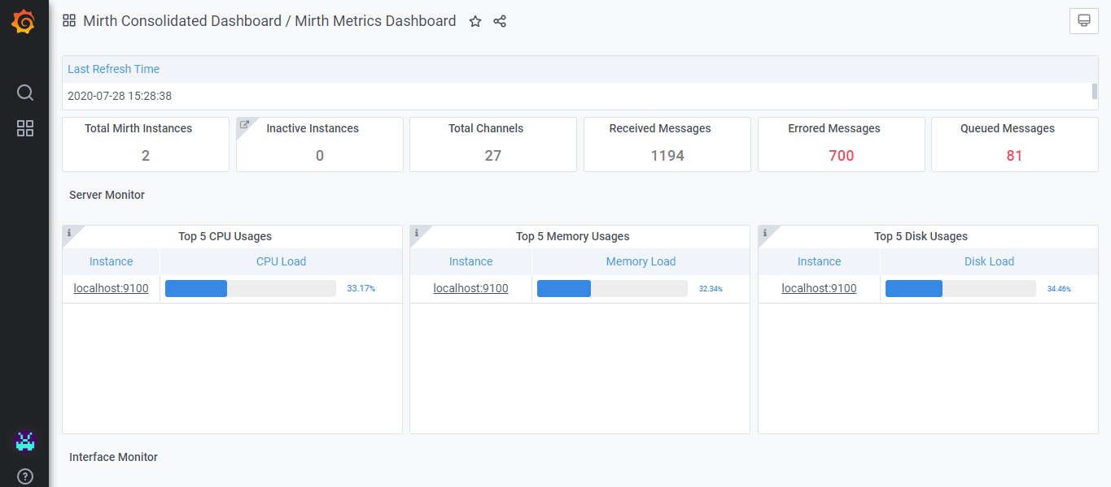

Server Monitor

Header

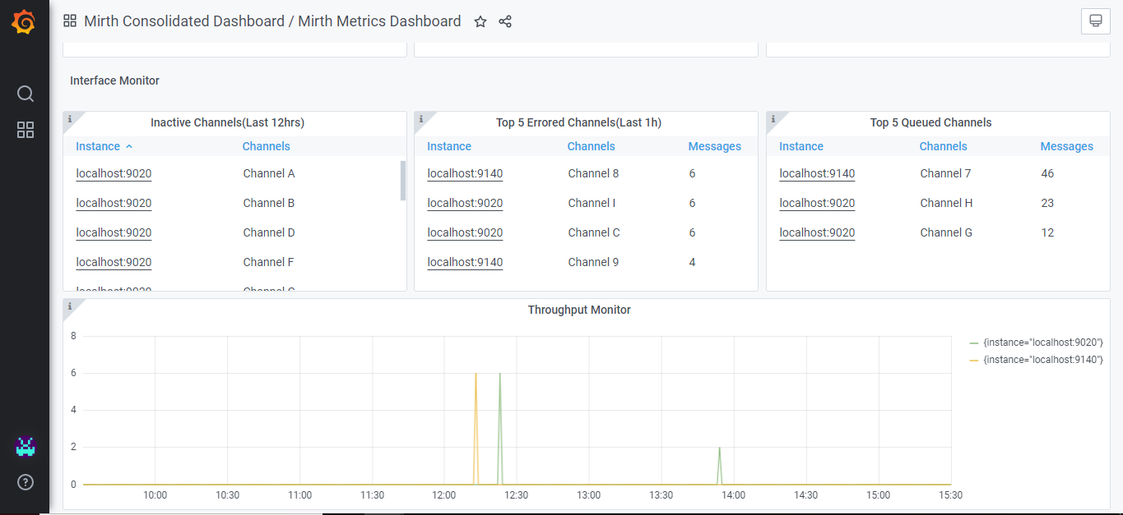

Channel Monitor

Throughput Monitor

1. This dashboard is refreshed every 5 seconds to display near real time values of metrices.
2. The top most section alternatively called as Header section of dashboard displays key metrices as follows :
   1. Total Mirth Instances : This displays the total number of Mirth instances deployed : ,
   2. Inactive Instances : Displays the number of inactive Mirth instances which have not received or sent any messages since last 12 hours,
   3. Total Channels : Total number channels configured on all the Mirth server instances deployed,
   4. Received Messages: Total number of received messages on all the Mirth server instances since last reset of the Prometheus services,
   5. Errored Messages: Total number of errored messages on all the Mirth server instances since last reset of the Prometheus services and
   6. Queued Messages: Total number of queued messages on all the Mirth server instances since last reset of the Prometheus services.

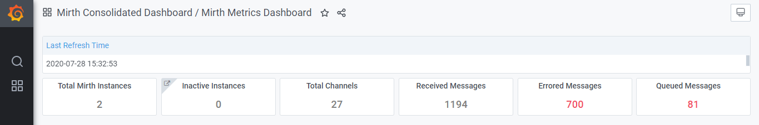

1. The section below the header section displays all the metrices related to Mirth server Health, hence it is called as ‘Server Monitor’ section. This section has following panels:
   1. Top 5 CPU usages: This panel displays the list of top by Mirth instances by percentage of CPU usage.
   2. Top 5 Memory usages: This panel displays the list of top by Mirth instances by percentage of Memory usage and
   3. Top 5 Disk usages : This panel displays the list of top by Mirth instances by percentage of Disk usage.

The Mirth instances are arranged in descending order of their CPU, Memory and disk usage respectively. User can drill down to view more details by selecting the instance name from any of these panels.

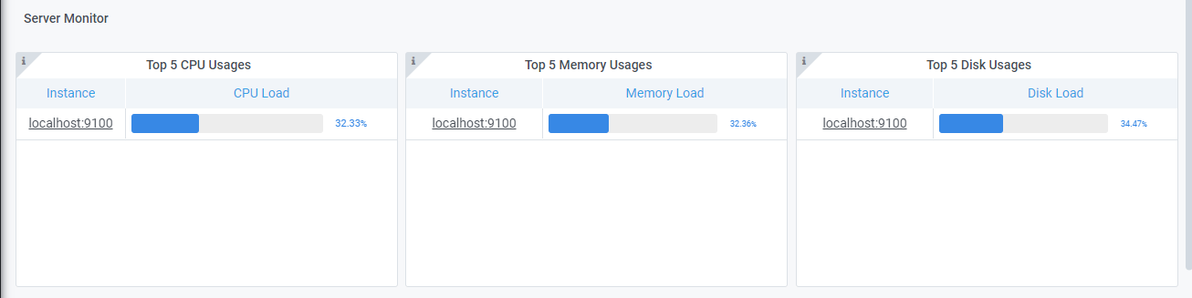

1. Section below Server Monitor Section is called as ‘Channel Monitor / Interface Monitor’ and it displays following panels:
   1. Inactive Channels (Last 12 hrs.) : This panel displays the list of Inactive Channels which haven’t received or sent any message since last 12 hours,
   2. Top 5 errored Channels (Last 1 hr.) : This panel displays the list of top 5 channels by number of errored messages arranged in descending order of number of errored messages,
   3. Top 5 Queued Messages : This panel displays the list of top 5 channels by number of queued messages arranged in descending order of number of queued messages,

The top 5 channels in each panel of errored and queued channels are arranged in descending order of number of errored and queued messages respectively. Server instance name in each panel can be selected to drill down in to more details of each metric.

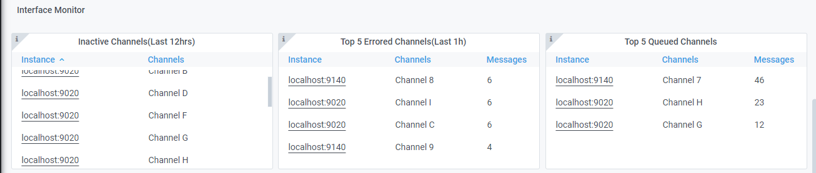

1. The section at bottom of the dashboard is named as ‘Throughput Monitor’ and it displays graphical representation of the number of messages sent by each Mirth Server instance every minute over last six trailing hours in the form of line graph. Each line in this graph represents one Mirth Server Instance.

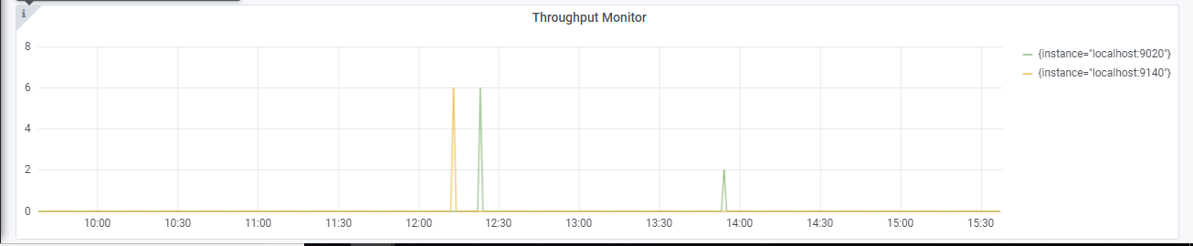

## Drill down Views:

### Drill down from Server Monitor Section:

1. Select instance name from each panel of the server monitor dashboard section to navigate to the CPU Details, Memory Details and Disk Details dashboards respectively.
2. The drill down screen from ‘Top 5 CPU Usage’ panel displays the list of all the deployed NextGen Connect instances in the descending order of their CPU usage.

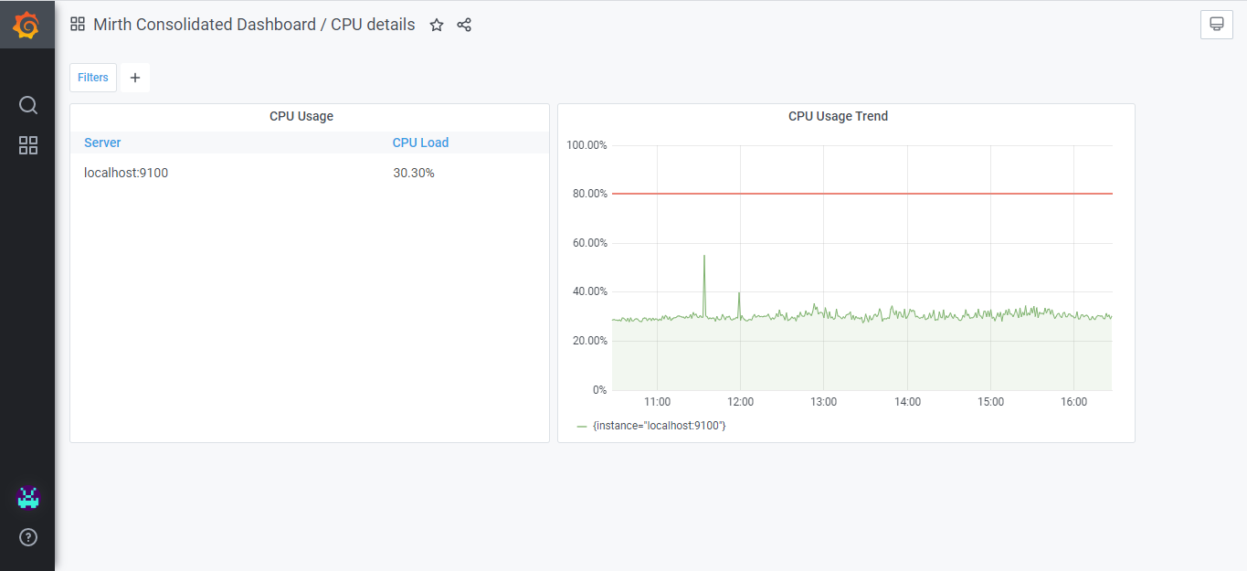

1. This screen also has the graphical representation of the trend of CPU usage of all the server instances in the form of line graphs over last six hours.
2. CPU usage values are highlighted when the usage percentages cross the threshold values. Users can also filter the list of instances by selecting the filter option on the top left corner of the screen.
3. Drill down view from ‘Top 5 Memory Usage’ and ‘Top 5 Disk Usage’ panel is similar to that of the ‘Top 5 CPU Usage’ drill down screens and lists down instances by their memory usage and disk usage respectively.

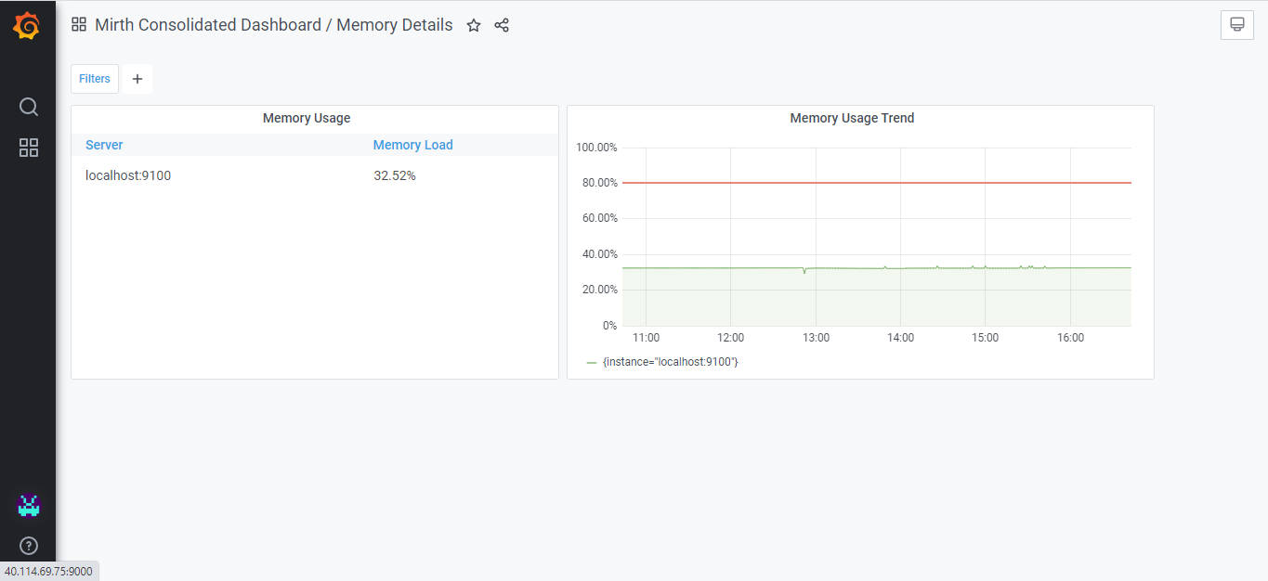

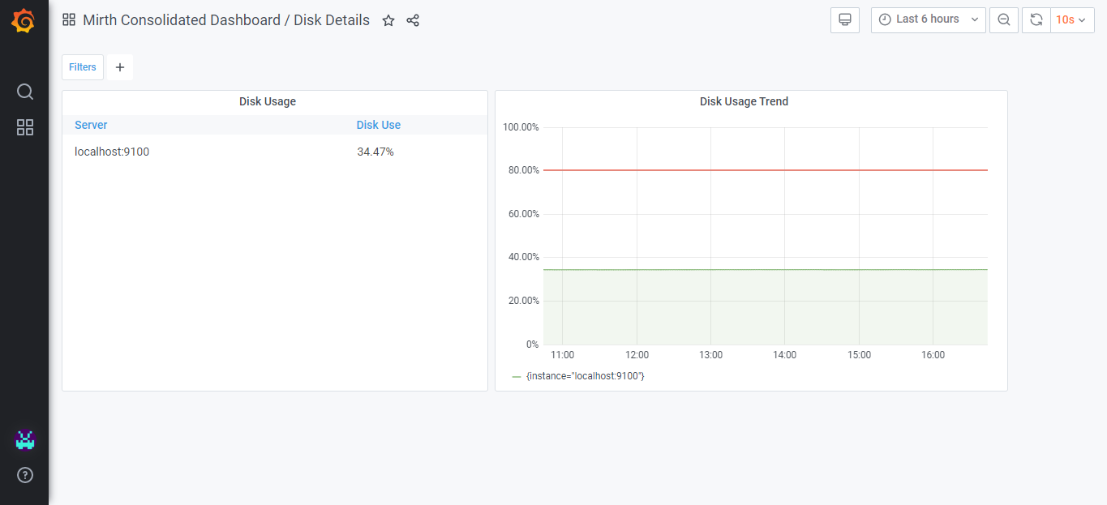

1. In order to filter a specific Mirth channel click on the ‘+’ icon in front of ‘Filter’ on the top left corner of the dashboard and then select the ‘Channel’ and specific ‘Channel Name’.

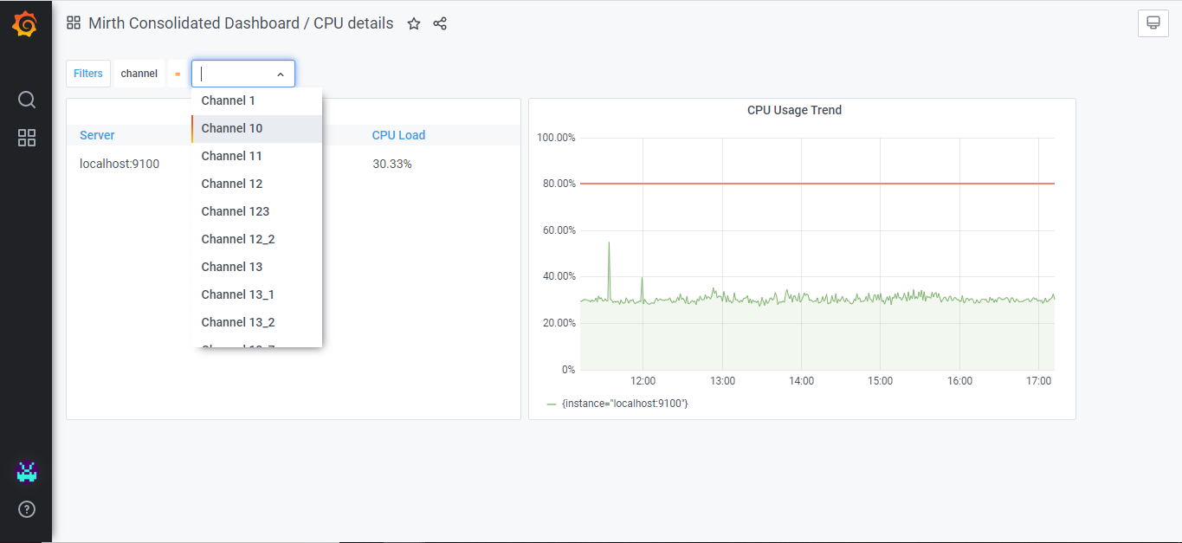

### Drill down from Interface/Channel Monitor Section

**Drill Down from ‘Inactive Channel’ section:**

1. Select the instance name from the ‘Inactive Channels’ panel of Channel Monitor to navigate to ‘Channel Metrics’ dashboard, where user is displayed the list of inactive channels and their corresponding instances.

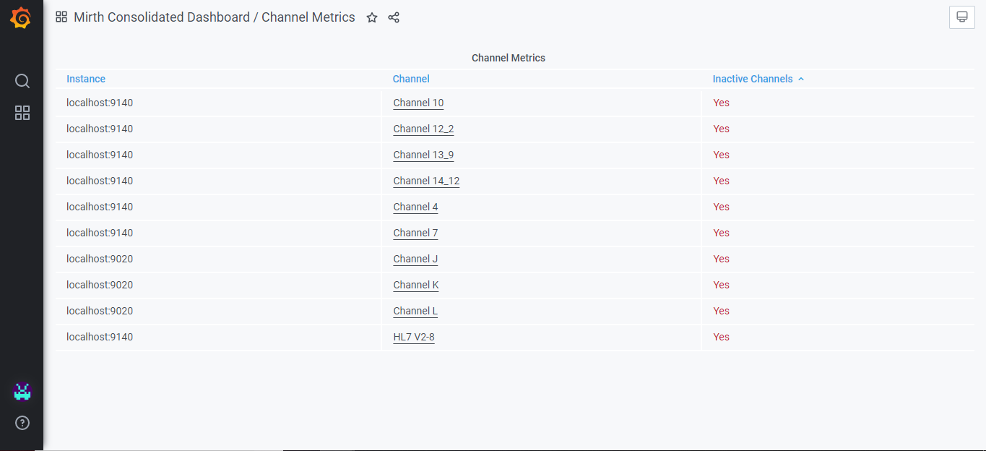

1. The inactive channels are the ones which have not received or sent any message since last 12 trailing hours.
2. Select a Channel name on the Channel Metrics screen to navigate to the ‘Channel Throughput Monitor’ screen , where user is displayed the graphical representation of sent messages via that channel in trailing last 6 hours in the form of a line graph.

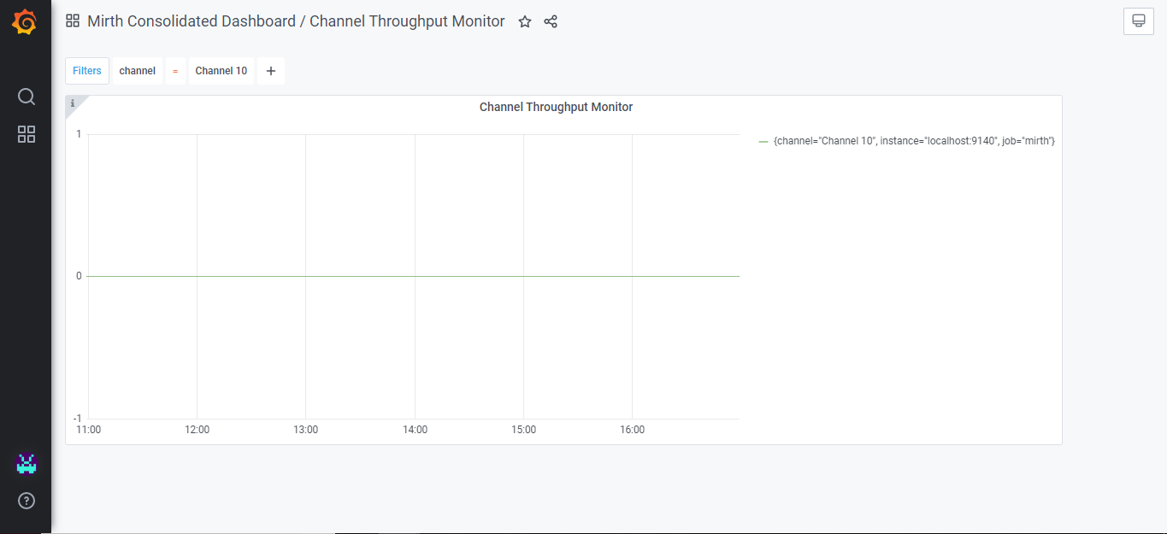

1. Click on the ‘+’ icon in front of ‘Filter’ on the top left corner of the dashboard and then select the specific ‘Channel Name’ to view the ‘Throughput Monitor’ for a specific Mirth channel.

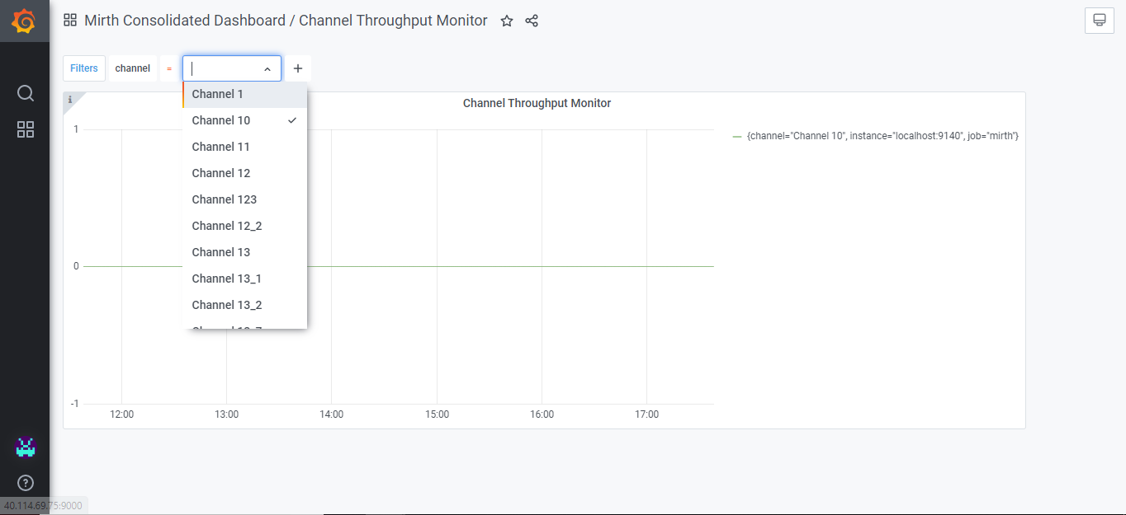

**Drill down from ‘Top 5 Errored Channels (Last 1 hr.)**

1. Select an instance name from the ‘Top 5 Errored Channels (Last 1 Hr.)’ panel to navigate to ‘Errored Channels’ dashboard, where users are displayed the list of channels with their corresponding server instance names, number of errored messages since last reset of Prometheus services and number of errored messages in last one hour.

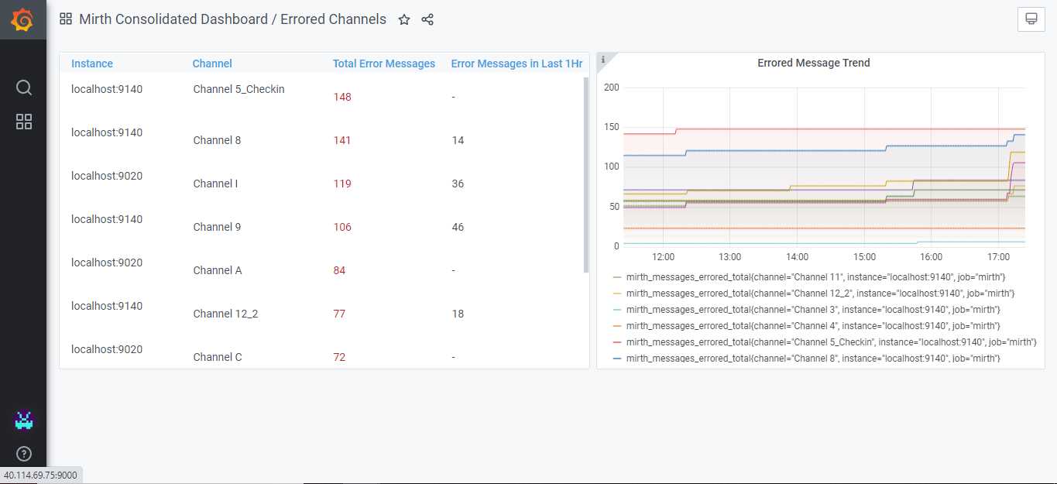

1. The list of channels is arranged in descending order of the total number of errored messages.
2. On the right side of the ‘Errored Channels’ dashboard, user is displayed graphical representation of the trend of errored channels in the form of line graphs. In this graph each line represents one channel.
3. No further drill down views or filters are available on this screen.

**Drill down from ‘Top 5 Errored Channels (Last 1 hr.)**

1. Select an instance name from the ‘Top 5 Queued Channels’ panel to navigate to ‘Queued Channels’ dashboard, where users are displayed the list of channels with their corresponding server instance names, number of total Queued messages on that channel since last reset of Prometheus services and an indicator indicating whether the drop in the sent message percentage is > 60 percent of its last 12 hour sent messages.

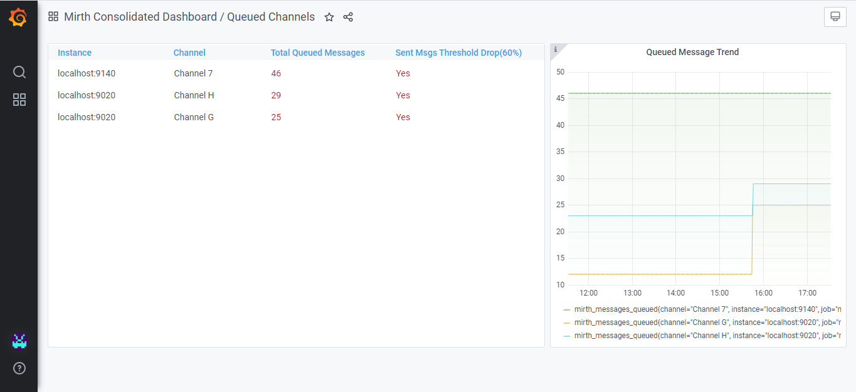

1. No further drill down views or filters are available on this screen.